# **Special Topics** (CSE 490-R)

## Training minutes – Weeks 3-4

|  |  |
| --- | --- |
| **Date of meeting:**  **Instructor:**  **Student:** | May 15, 2022  Bro. Clements  Guillermo Oliva |

* **Notes taken from lecture**
  1. The article “Elements of Software Configuration Management” (SCM) is the first document that presented software versioning control.
  2. GitHub is a product of the SCM article listed above.
  3. Some of the configurations listed in the “Elements of Software Configuration Management” include:
     1. SCI, ECP, SCCB, DO, and CCC [This are terms that can be found on the article. They are critical for the SCM]
  4. 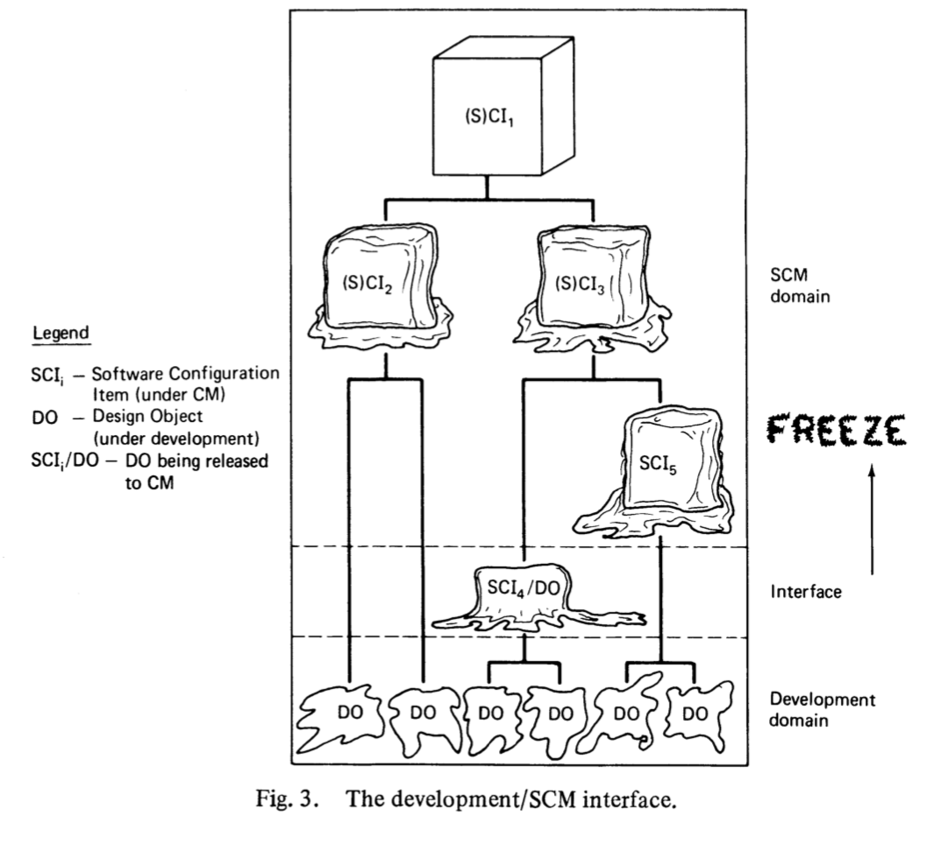The article introduces the “Development/SCM Interface”:
  5. The article introduces the SCI workflow on a single document: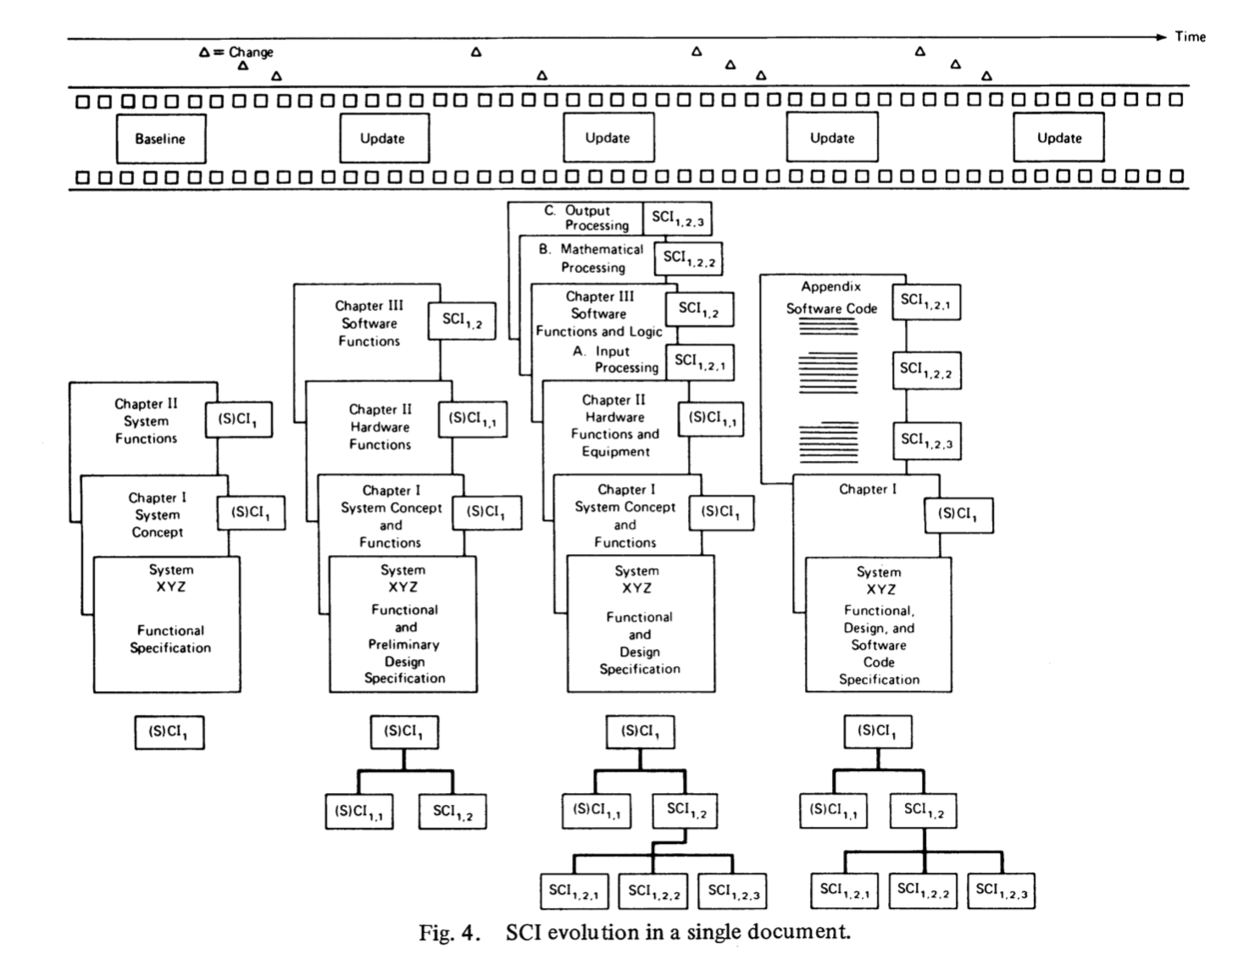
  6. The article can be accessed from this link: <https://ieeexplore.ieee.org/document/5010202>
  7. The following an example of a normal workflow (presented by Bro. Clements):
     1. 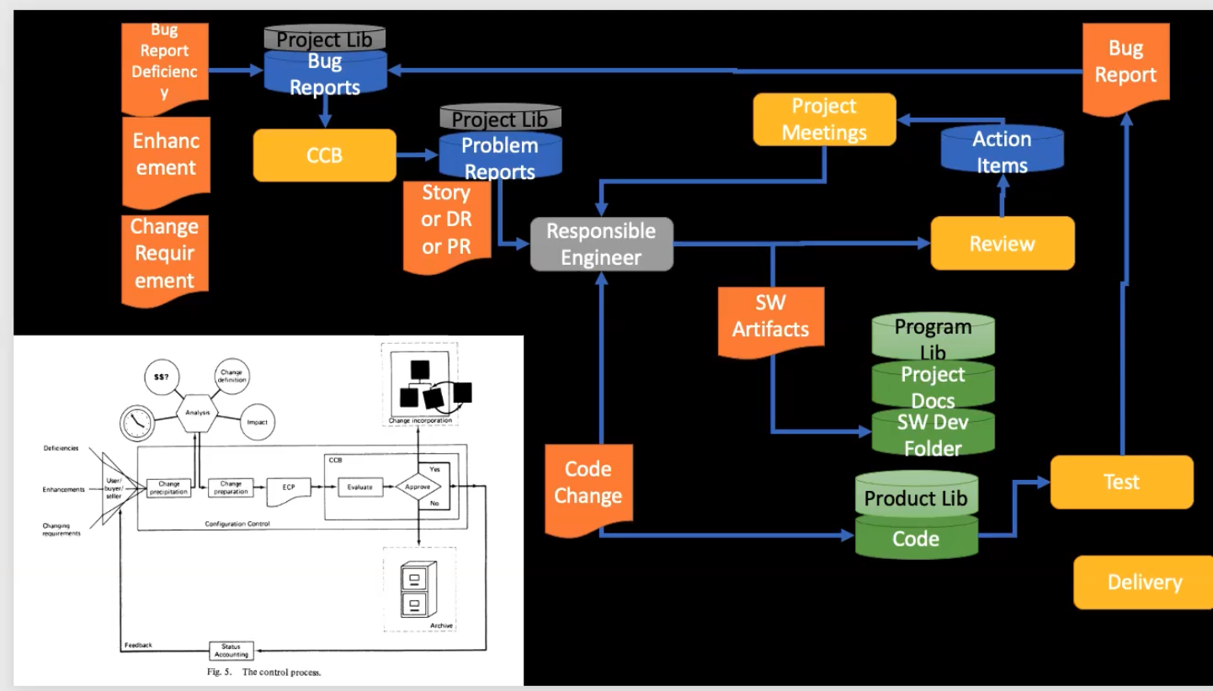
  8. The are bug reports repositories that are used to create stories on a daily basics (part of the software development)
  9. As things get completed, they get tested to validate completion.Things get also peer reviewed.
  10. The product library needs to be versioned control, otherwise there is a risk of losing the work put on the project. It is recommended to use libraries repositories such as GitHub, GitLab, etc.
  11. 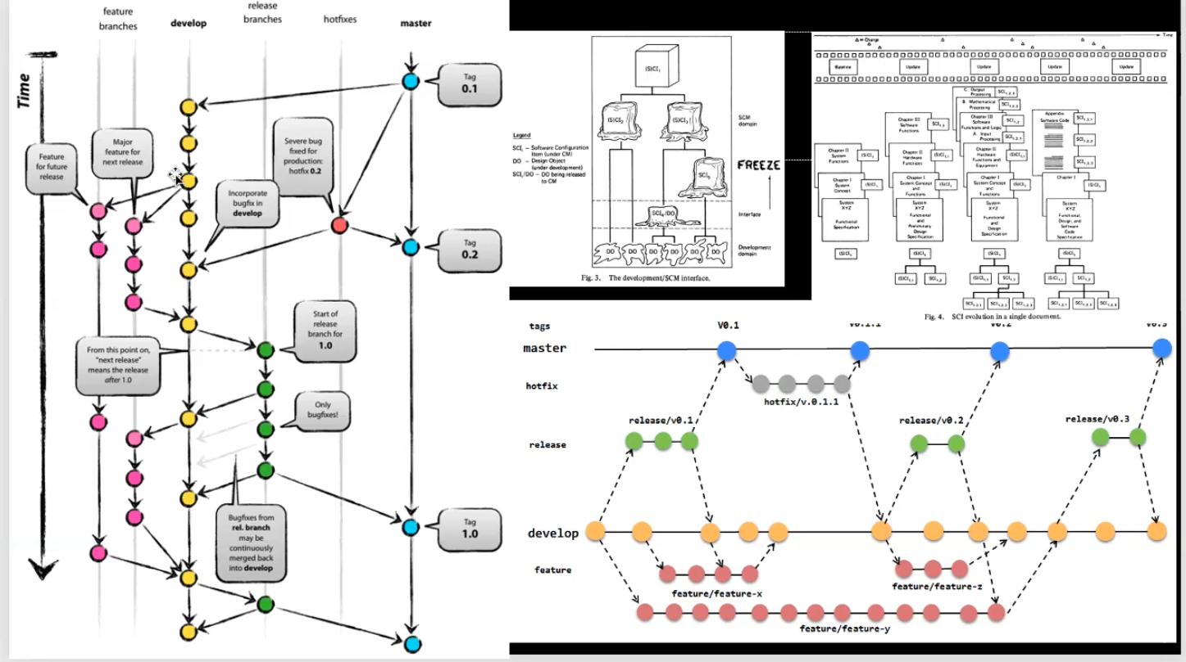Example of the nodes as things get checked in:
  12. 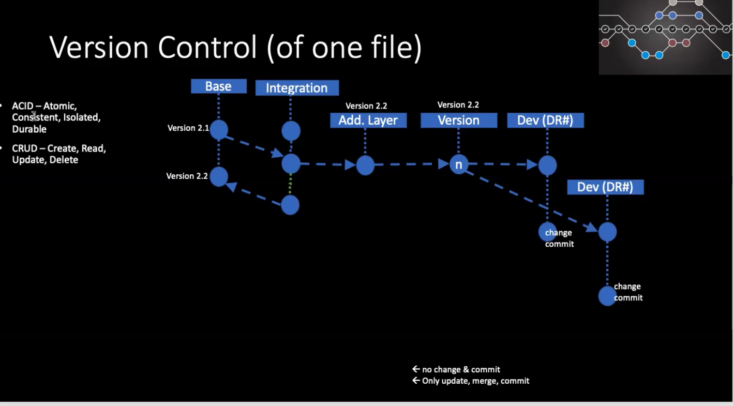Example of version control of one file:
  13. 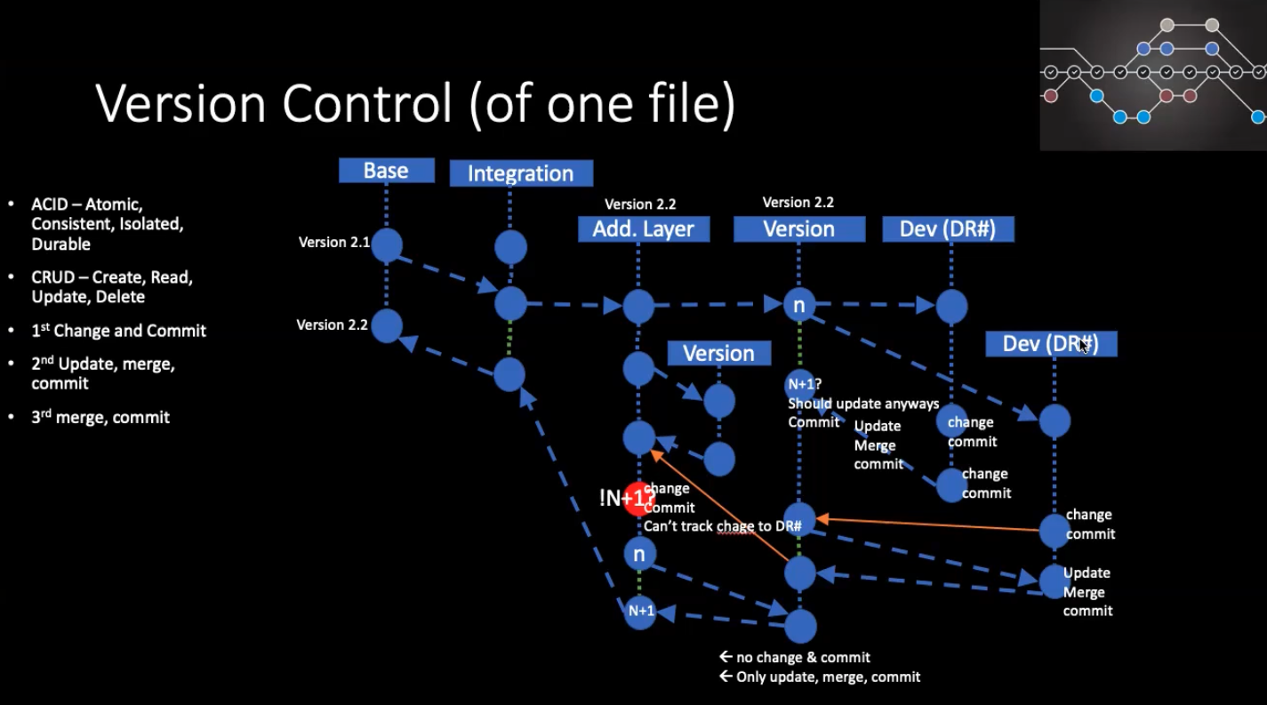Example of the version control with a greater level of complexity:
  14. In order to be able to merge change, the branch must be at N + 1 state, so a pull is always needed before being to commit to the parent branch.
  15. 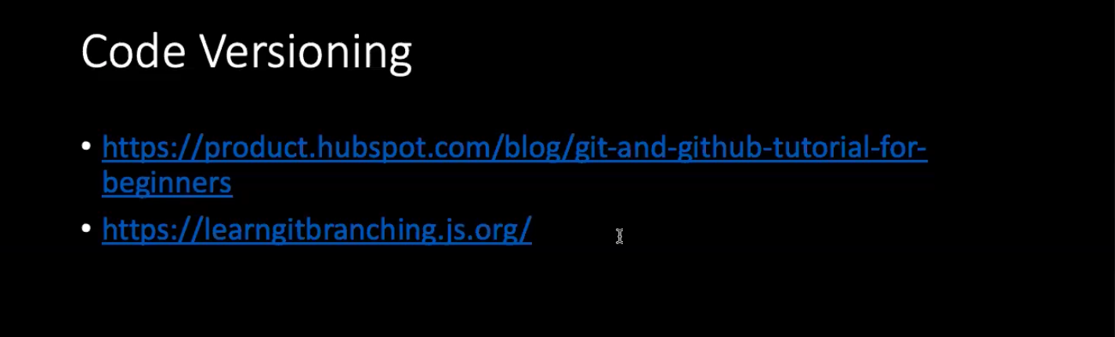There is certification available for code versioning (some companies require the certification in order to be considered for a position), some recommended links by Bro. Clements are: